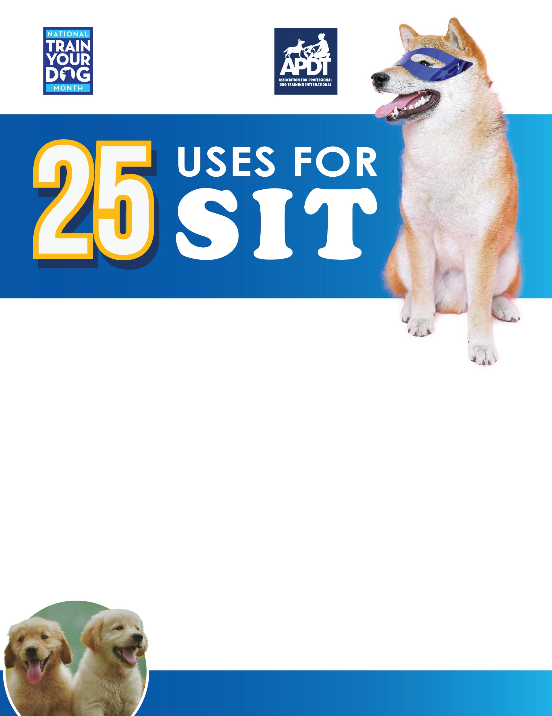

[**www.TrainYourDogMonth.com**](http://www.TrainYourDogMonth.com) **|** [**www.APDT.com**](http://www.APDT.com) **| [www.MyDogHasClass.com](http://www.MyDogHasClass.com)**

1. **Sit at the door when guests enter (no jumping up!).**
2. **Sit to have the leash and collar put on before going outside.**
3. **Sit when the front door opens for a walk and wait until released to move forward.**
4. **Sit in the kitchen to avoid counter-surfing.**
5. **Sit while food is being served at the dinner table.**
6. **Sit while food bowls are being put down to prevent rushing toward the bowl.**
7. **Sit before getting in the car so you can load your dog first.**
8. **Sit when you open the car door so your dog doesn’t jump out into traffic.**
9. **Sit calmly to have front feet dried off during rainy or muddy weather.**
10. **Sit patiently while the owner pets or treats other dogs in the household.**
11. **Sit and stay while the owner pays for items at the pet supply store.**
12. **Sit and stay while others pass by when you’re on an off-leash hike.**
13. **Sit and stay to keep the dog from becoming overstimulated in exciting situations.**
14. **Sit to give a “high five” as a trick.**
15. **Sit to perform the “say your prayers” trick.**
16. **Sit to do the “sit up and beg” trick.**
17. **Sit before taking down the baby gate or coming out of the crate**
18. **Sit and stay during a walk when you stop to pick up after your dog.**
19. **Sit at sidewalk curbs and wait until it’s safe to cross the street.**
20. **Sit and look at you instead of barking at other dogs during a walk.**
21. **Sit to prevent your dog from running off.**
22. **Sit to have nails clipped on the front paws.**
23. **Sit while you get your keys out at the front door.**
24. **Sit at the top or bottom of a staircase to avoid tripping over your dog.**
25. **Sit before the owner throws a favorite toy. Repeat for each toss.**

**Your Local APDT Member**