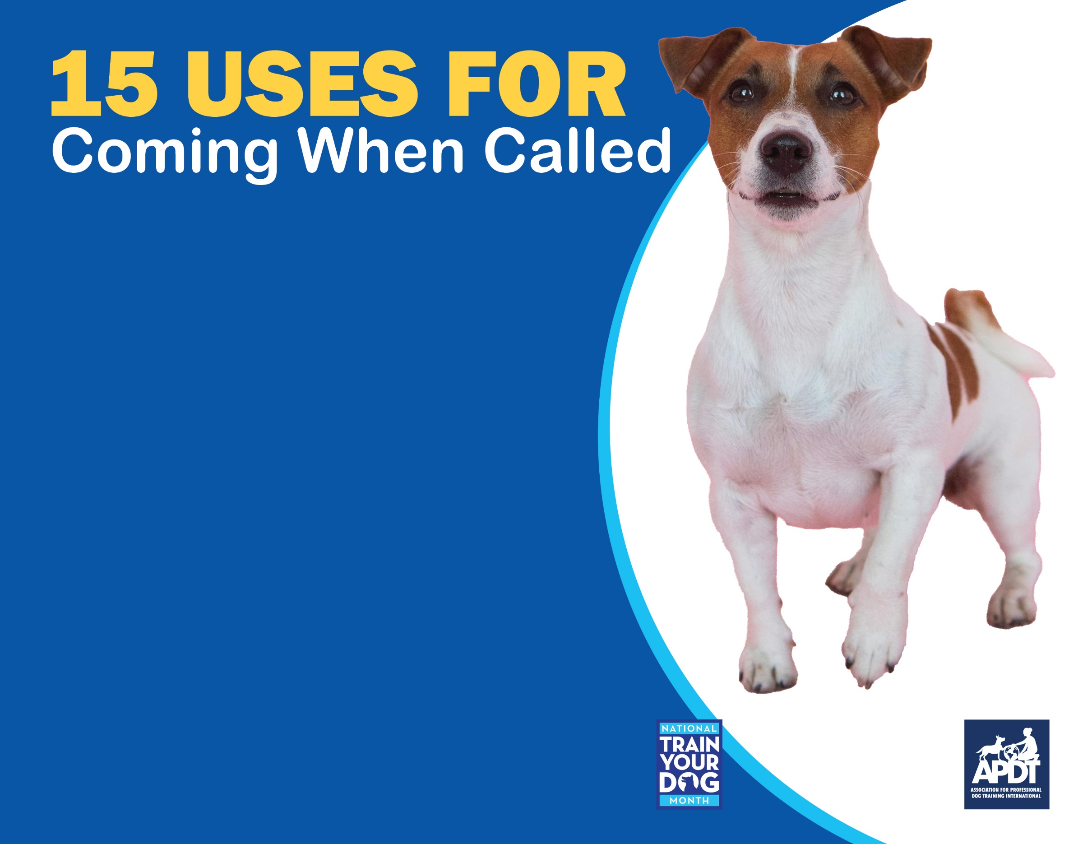

**Your Local APDT Member**

[**www.TrainYourDogMonth.com**](https://trainyourdogmonth.com/) **|** [**www.APDT.com**](https://apdt.com/) **| [www.MyDogHasClass.com](https://apdt.com/class/)**

1. Call your dog back to you if he runs out the door.
2. Call your dog away from barking at squirrels out the window.
3. Call your dog back into the house if he’s barking at something in the yard.
4. Call your dog away from bothering the cat.
5. Call your dog when it’s time for a walk or to go for a drive.
6. Call your dog off of spilt food or toxic items on the ground.
7. Call your dog when he’s starting to bother your other dog (e.g., a puppy annoying an older dog).
8. Call your dog as emergency cue when dog is running off or toward danger.
9. Call your dog to do something he enjoys (make sure your dog learns “come” means good things will happen!)
10. Call your dog away from the door when the doorbell rings.
11. Call your dog away from the mail coming through the mail slot.
12. Call your dog when you’re ready to feed him his dinner.
13. Call your dog to you at the dog park or dog beach to keep him from pestering other dogs or people.
14. Call your dog back to shore when he’s swimming in the lake or ocean too far out.
15. Call your dog during games with the family, like hide and seek