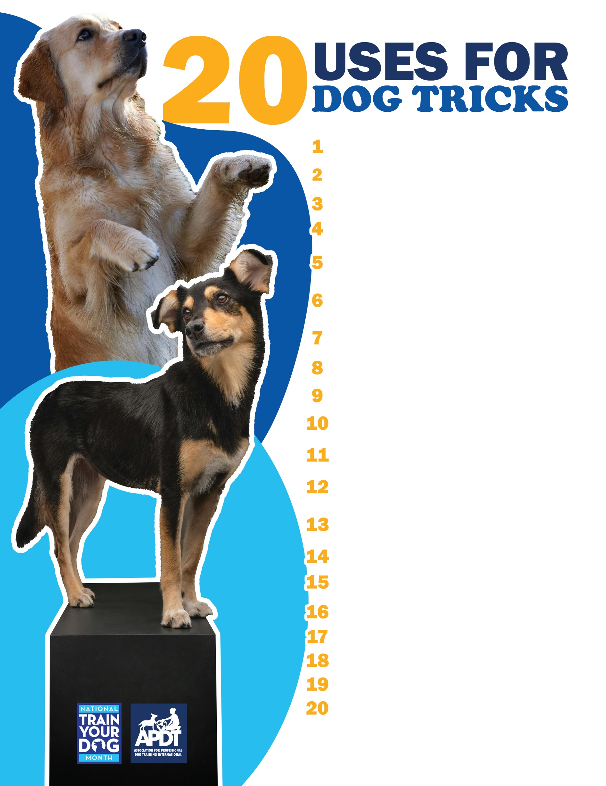

**Your Local APDT Member**

[**www.TrainYourDogMonth.com**](https://trainyourdogmonth.com/) **|** [**www.APDT.com**](https://apdt.com/) **| [www.MyDogHasClass.com](https://apdt.com/class/)**

**Tricks can distract a reactive dog from something that scares him.**

**Tricks make you laugh!**

**Tricks engage the entire family, particularly children.**

**Tricks can be useful. For example, teach your dog to get your slippers or bring in the newspaper on rainy days.**

**Tricks are entertaining and they can make people think you and your dog are both geniuses!**

**Tricks provide a way to practice your dog’s “manners.”**

**Tricks are more fun to teach for people “put off” by obedience: “Bang you’re dead” is the same behavior to your dog as “down”—but you have fun with it!**

**Tricks increase your dog’s repertoire of behaviors. The more your dog learns, the better your dog learns and the more mentally engaged he will be.**

**Tricks can be used to help endear your dog to someone not traditionally a dog lover.**

**Tricks allow you to “show off” what you’ve accomplished with your dog.**

**Tricks add variety to training.**

**Tricks can be used to solving jumping on people: A dog who jumps to greet people could be taught to sit and wave instead.**

**Tricks can be used to solve barking: A dog who barks at visitors could be taught to go get a toy and hold it in his mouth instead.**

**Tricks are a great way to strengthen the dog-owner bond. People are relaxed when teaching tricks and it’s great fun for dog and owner.**

**Tricks can help make shelter dogs more adoptable.**

**Tricks can make breeds with a “bad reputation” look friendlier.**

**Tricks make the learning process for children (and adults!) more enjoyable.**

**Tricks can be entertaining for people on therapy visits at places like hospitals.**

**Tricks can be practiced indoors or out, regardless of the weather.**

**Tricks engage your dog’s mind and provide mental exercise.**