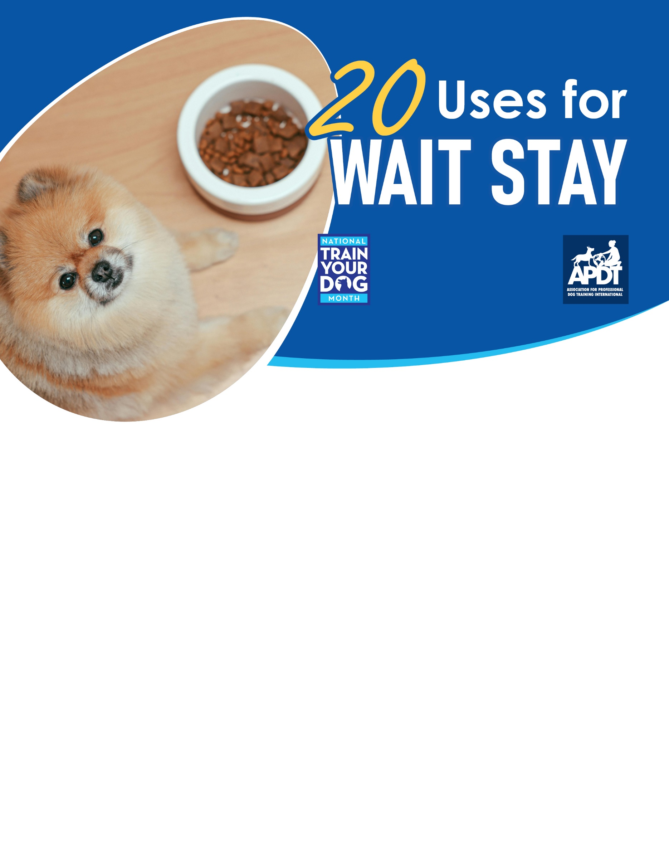

[**www.TrainYourDogMonth.com**](http://www.TrainYourDogMonth.com) **|** [**www.APDT.com**](http://www.APDT.com) **| [www.MyDogHasClass.com](http://www.MyDogHasClass.com)**

1. **Wait/stay while you put on your dog’s leash and collar before a walk.**
2. **Wait/stay prevents your dog getting to something you drop, such as a chicken bone.**
3. **Wait/stay to help teach your dog self-control.**
4. **Wait/stay to keep your dog from rushing other people or dogs.**
5. **Wait/stay while allowing another dog or person to pass by.**
6. **Wait/stay on a walk when you stop to pick up after your dog.**
7. **Wait/stay while owner pays for items at the pet supply store.**
8. **Wait/stay to keep dog from getting over-stimulated by any exciting situation.**
9. **Wait/stay to keep your dog from rushing into the house before you can clean his paws from a muddy or wet back yard, or after he’s jumped in the pool and he’s all wet!**
10. **Wait/stay allows you to enter through a doorway first, useful if you’re carrying something such as bags of groceries and you don’t want to have dogs underfoot in the doorway!**
11. **Wait/stay to keep dog from jumping into or out of the car before you’re ready for him to.**
12. **Wait/stay to keep dog from rushing out the front door.**
13. **Wait/stay to keep dog from counter surfing in your kitchen.**
14. **Wait/stay before released to eat meal you’ve presented.**
15. **Wait/stay at dog park for you to unclip leash to let dog run.**
16. **Wait/stay at doorways when needed (e.g., to back yard).**
17. **Wait/stay at the top/bottom of stairs prevents your dog from tripping you.**
18. **Wait/stay prevents your dog jumping up on guests.**
19. **Wait/stay prevents your dog from “taking candy from the baby.”**
20. **Wait/stay puts your dog in a relaxed “down” during your dinner.**

**Your Local APDT Member**