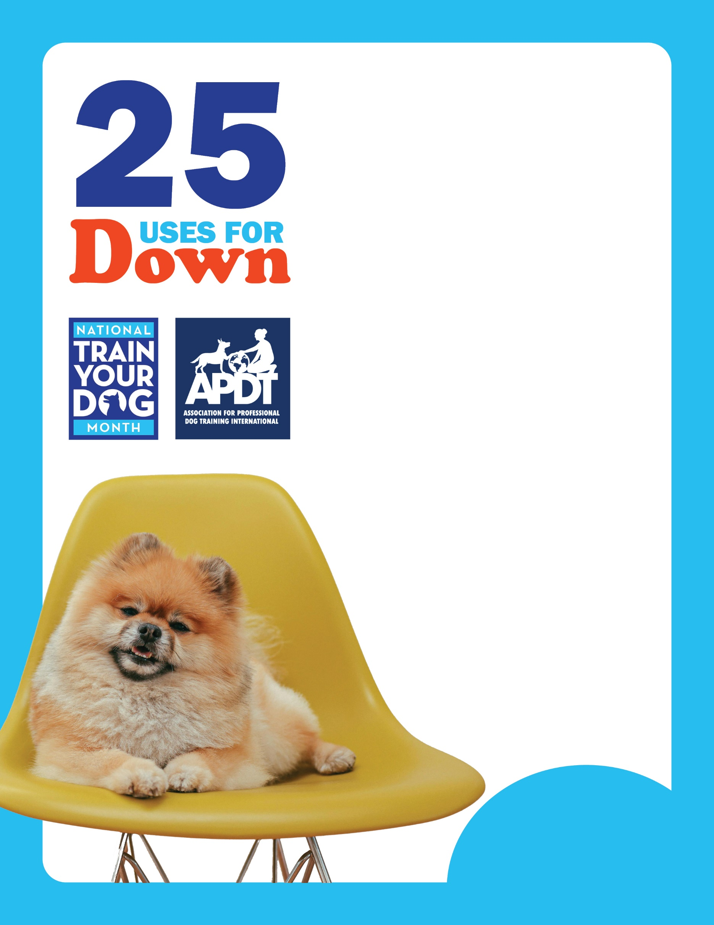

1. **Down for a veterinary exam.**
2. **Down for husbandry tasks such as clipping back nails.**
3. **Down as emergency cue when dog is running off or toward danger.**
4. **Down stay while family eats a meal.**
5. **Down stay on a mat away from door when visitors enter home.**
6. **Down stay when encountering something you need to go deal with (e.g., something dangerous like a snake, helping someone who’s fallen down).**
7. **Down stay while dinner is being prepared.**
8. **Down stay while working with another dog in the house.**
9. **Down stay while you are doing sit ups or yoga.**
10. **Down stay while you are getting the children ready to leave for school.**
11. **Down stay when being petted by small children.**
12. **Down on a mat with a bone or chew when the family wants to relax at night.**
13. **Down stay can discourage some dogs from barking at other dogs in a class.**
14. **Down to prevent your dog from running off.**
15. **Down at the door to stop your dog from jumping on guests.**
16. **Down at the door to prevent your dog rushing out when you open it.**
17. **Down and roll on his side for grooming.**
18. **Down and relax while you’re watching TV or using your computer.**
19. **Down and relax while you visit with friends and relatives.**
20. **Down stay to prevent your dog being underfoot when you’re working in the kitchen/busy.**
21. **Down stay at family gatherings such as birthday parties.**
22. **Down stay at outdoor events such as kids’ soccer games.**
23. **Down stay on a walk when you stop to pick up after your dog.**
24. **Down to teach the “rollover” trick.**
25. **Down to teach the “play dead/go to sleep” trick.**

[**www.TrainYourDogMonth.com**](http://www.TrainYourDogMonth.com) **|** [**www.APDT.com**](http://www.APDT.com) **| [www.MyDogHasClass.com](http://www.MyDogHasClass.com)**

**Your Local APDT Member**