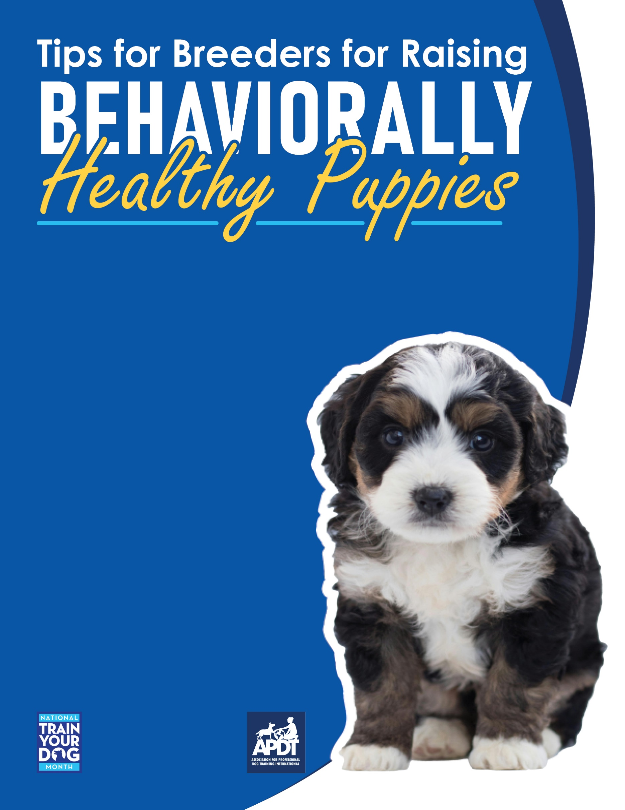

**Your Local APDT Member**

The time a puppy spends with the breeder is the most critical time in his development into a healthy adult dog. During this time, the puppy learns

critical life skills from his mother and littermates as well as his environment and human caretakers. The lessons learned during this time are

invaluable in creating a developmentally sound dog. Early separation from the litter can have devastating effects on a puppy’s normal

development.

A puppy’s littermates are notably the best teachers of appropriate play, including bite inhibition. The feedback a puppy receives from his littermates helps him develop an understanding of how he can, and cannot, use his mouth and he will

also develop an understanding for the rules of healthy play. Play in itself is a multifunctional te-

aching tool, teaching not only a set of “rules” to abide by for polite play but also helping to

develop behaviors necessary for survival as an adult. Through play and interac-

tions with the mother and litter mates, the puppy is also able to learn to read

and display “dog language.” This knowledge is essential in communicating

with other dogs (and people!) as an adult. When taken away from the litter

too soon, many dogs never develop good communication skills or learn

how to engage in appropriate play. Tolerance is also learned among lit-

termates through play and other interactions. More specifically, frustration

tolerance is learned as resources are sought between littermates. The so-

cial skills learned through interaction with the puppy’s littermates are a ve-

ry valuable benefit, and are hard for human caretakers to recreate.

It should also be noted that a puppy experiences most of his socialization

period while with the breeder, so it is essential that special procedures are

in place to ensure the puppy begins the process of socialization to novel

people, events, environments, sounds, substrates, dogs and other animals.

Critical socialization begins in the first few days of life, even before a pup-

py’s senses are fully functioning, and ends, debatably, somewhere between

12 and 16 weeks. Shortly after birth, the breeder should begin to handle the

puppies daily. Hands should be thoroughly washed, and each puppy should

then be gently handled for just a few minutes, and then returned to the mo-

ther. This is will help the puppies become used to human touch and also fur-

ther promote frustration tolerance as a mild stress is placed upon each pup-

py in the absence of their mother and littermates. At 3 to 4 weeks of age, the

puppies’ senses are more developed, and they can begin to be handled more

vigorously.



[**www.TrainYourDogMonth.com**](https://trainyourdogmonth.com/) **|** [**www.APDT.com**](https://apdt.com/) **| [www.MyDogHasClass.com](https://apdt.com/class/)**

All parts of their body, including gums, tail and feet should be touched, to habituate them to examination and extensive human handling. At this time, puppies should also experience short periods of separation to further promote healthy frustration tolerance and habituate them to periods of isolation. Although it has not yet been proven, it is believed that these periods of isolation at a young age can prevent separation anxiety from presenting at a later time in the puppy’s life.

When the puppy is transitioning from mother’s milk to solid food and thereafter, it is imperative that caretakers are present at feeding time. Caretakers should make a habit of stroking the puppies during meal time as well as touching their food, removing their bowl and allowing other puppies near the food. When the caretaker approaches, strokes the puppy, takes the food away or another animal approaches, the puppy should be given a piece of extra scrumptious food reward to promote a positive association with the presence of humans and other animals around the puppy’s food. This will teach the young puppies to accept others during mealtime and alleviate much of the threat that food aggression will present at a later time.

At this same time, further exposure to novel stimuli should begin. The puppies should be exposed to a number of different people during the socialization period. This includes many different types of people, including children, large men, etc. However, the people chosen to socialize the puppies with should have a clear understanding of what you are trying to accomplish. Simple exposure does not ensure proper socialization. The experience must be positive, thus friendly, non-abrupt or non-abrasive people should be asked to participate in the puppies’ socialization. They should handle the puppies as instructed above. The same goes for socialization with dogs and other animals. The other animals should be chosen based upon their personality as a play session with an unfamiliar dog that is too rough, possibly aggressive, or socially inappropriate will only hinder socialization and possibly promote a generalized fear of dogs to present later in a puppy’s life. Although the exact timing is widely debated, young puppies go through several “fear periods” in which fears are rapidly imprinted and can surface at any time in the puppy’s adult life. Extra precaution must be taken to ensure positive experiences occur during this time.

The same positive experiences should be extended to include a number of different environments, substrates, sounds and other novel events. Both the breeder and a puppy’s new owner should continue to promote socialization through positive experiences with a countless number of novel stimuli. By meeting many people and animals, visiting a number of novel places (including veterinarians, groomers and boarders), being exposed to many different sounds and other novel situations, proper socialization begins and the potential for later problems of fear and aggression can be minimized.

Finally, during this time, puppies learn faster than at any other time in their life, so obedience training should begin. Along with basic obedience, “manners” are easily acquired at a young age as well. Starting out teaching the right behaviors can save you from a lot of grief later on when going back to “fix” undesirable behaviors. Do not stop teaching them at 16 weeks. A healthy dog is continually socialized and trained throughout its life!