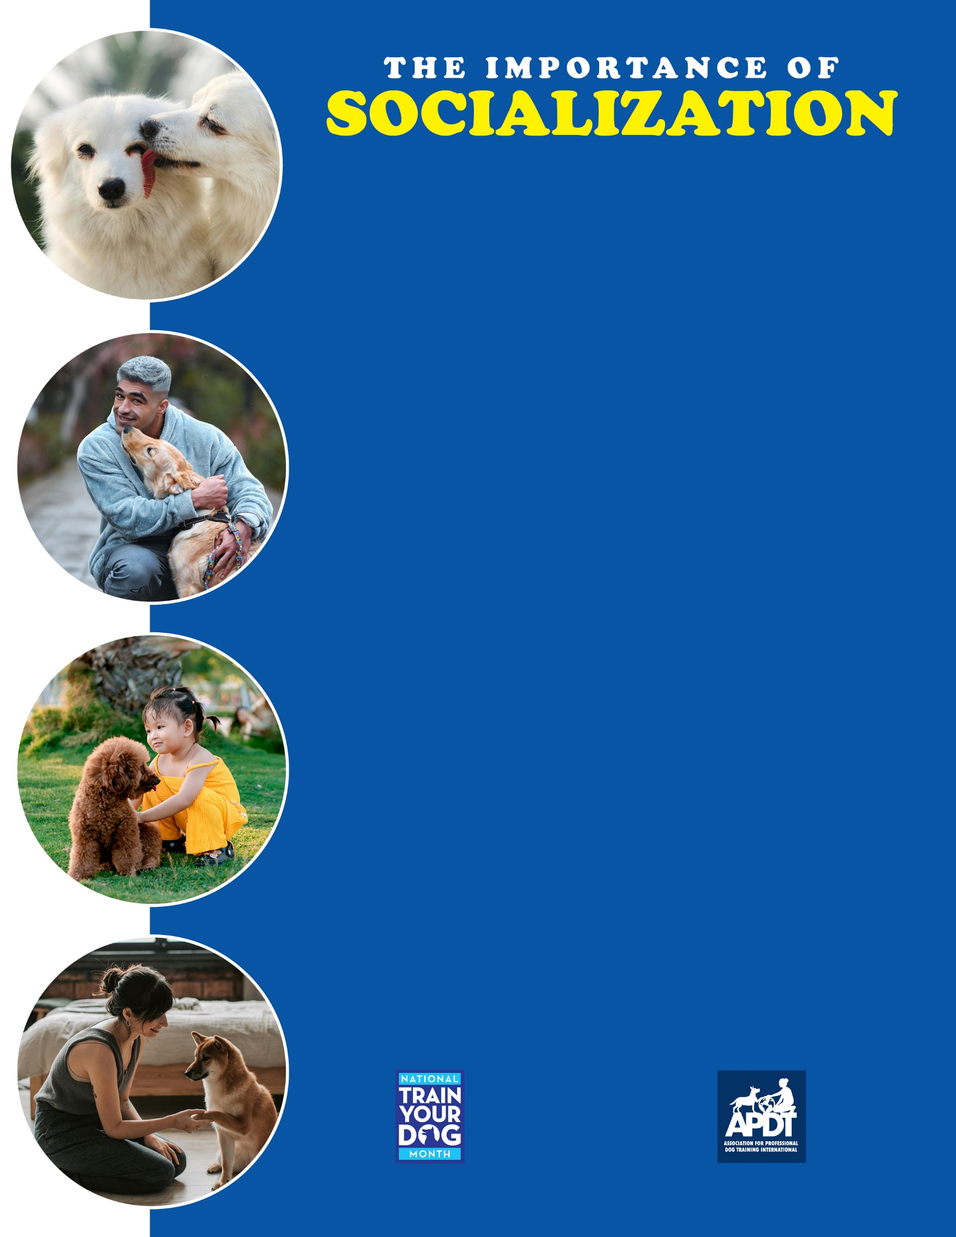

**Socialization includes:**

* ***People*** — from infants to the elderly. Different ages, sizes, ethnicities; glasses, hats, mustaches and beards, different clothing — anything you can think of.
* ***Places*** — new environments such as urban areas, country settings and everything in between. Nothing attracts friendly people more than an adorable puppy, so taking your puppy to new places gets him used to loads of people, too. Visit friends’ homes, your kids’ soccer games, and take quiet walks in the park.
* ***Things*** — Dog-friendly cats and other pets, household appliances, cars, buses, fire hydrants, trees and flowers. Virtually everything may be new to your puppy, so don’t be limited thinking that it’s something he’s likely seen before.
* ***Activities*** — Pleasant car rides, an elevator ride, and the like. And of course, Puppy Class is one of the best places to socialize. Plus you’ll both learn a lot!

**Safe socialization:**

Safe socialization: It’s important that exposure to all these new and novel experiences is positive and without stress. Here are some guidelines to help keep things stress-free and constructive:

* ***Have fun!*** Your positive attitude toward new things is important for your puppy
* ***Let your puppy approach new things on her own*** Provide the opportunity for your puppy to investigate and let her take her time.
* ***Respect your puppy’s feelings.*** Don’t push or force your puppy if he’s at all reluctant. Try laughing and interacting with the new object yourself, but ultimately err on the side of caution if your puppy thinks something is just too scary right now.
* ***Use common sense and be careful that all experiences are positive***. Avoid situations, people and environments that you think might result in a less-than-happy experience for your puppy. For example, in meeting a well-behaved child that wants to hold the puppy, have the child sit on the floor to avoid the possibility of a squiggly puppy falling from their arms and getting injured.

While there is little risk to socializing your puppy in public, there is a small possibility your puppy will be exposed to illness. Professional groups including the APDT and the American Veterinary Society of Animal Behavior (AVSAB) believe that the profound advantages of socialization far outweigh the minimal risk of illness. Ultimately, however, the decision is yours, and should be made in consultation with your veterinarian.

In the age-old discussion of “Nature versus Nurture,” the fact is both are important. “Nature” is what your puppy or dog is born with, and “nurture” is what you provide for a happy, healthy, affectionate, well-adjusted, and well-mannered dog. A critical aspect of “nurture” is socialization. Its importance cannot be underrated in raising a psychologically healthy puppy. In fact, providing your puppy with a broad range of experiences prior to the age of four months of age has been proven to be one of the most critical factors in raising a stable, confident dog.

Socialization is introducing your puppy to a broad range of new experiences, people, environments and activities. While you likely can’t expose a puppy to everything he or she may encounter in the future, the good news is that positive exposure to a wide variety of novel experiences results in a dog that easily adjusts to new things throughout his or her life. A well-socialized dog isn’t frightened of something he or she may never have experienced previously. In other words, well-socialized dogs are more secure, confident and self-assured.

**Your Local APDT Member**

[**www.TrainYourDogMonth.com**](https://trainyourdogmonth.com/) **|** [**www.APDT.com**](https://apdt.com/) **| [www.MyDogHasClass.com](https://apdt.com/class/)**