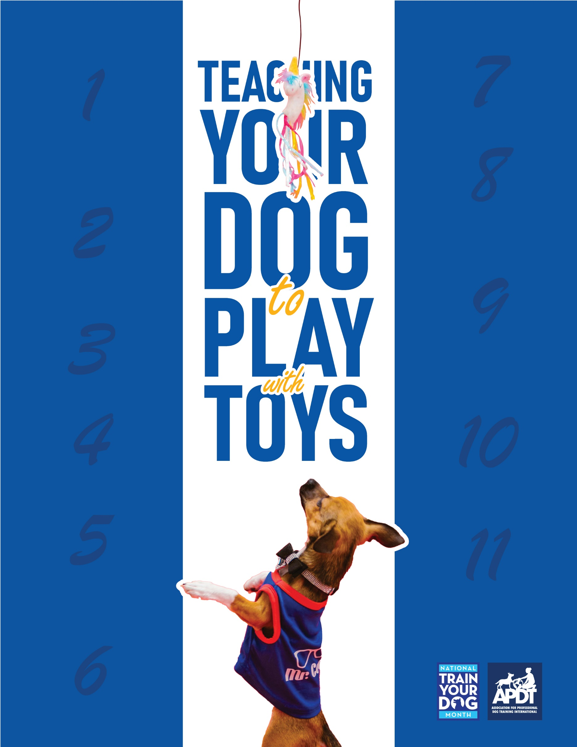

**Your Local APDT Member**

Always end the game while the dog is still active and happy. Again, the idea is to leave the dog always wanting more and anticipating more, rather than ending when he feels like it and is tired and bored.

As you play the game, slowly allow the dog to get the toy. You will be allowing him access to it in tiny increments, i.e. first time he might get his mouth on it for a second before you take it away, second time he might get his mouth on for 2-3 seconds, before you take it away, etc. Work on building this up until the dog is holding the toy in his mouth and you can engage in some tug play.

Remember to act particularly excited and goofy when the dog does get his mouth on the toy. You want to work on hyping him up at these moments so he builds up a desire to have and hold the toy in his mouth.

Repeat the above a few times a day as you have time. Always give a good amount of time in between intervals, so that the dog has relaxed, calm, “bored” time between each play session.

Continue the above for about 2-3 minutes, and then take the toy and put it away. You want to end the fun before the dog gets tired of the game, and while he is still building anticipation getting for the toy.

Take the toy and throw it. If your dog runs after it, run with him and grab it before he can get to it, and repeat teasing him and playing with it. Another way to do this is to attach a cord or fishing line to the toy, so that when you throw it, you can pull it back away from the dog before he can get to it.

Start to play with the toy yourself, throwing it in the air, swinging it around your body, teasing it in front of the dog’s face, swinging it between your legs, etc. Act excited and goofy, this is no time for maintaining one’s self respect!

Go and get the toy, while continuing to chatter to him excitedly, and show the toy to your dog – be real dramatic, like you just pulled out a big beef sirloin or a rabbit out of a hat!

Tease your dog with excited, goofy chatter about the toy – i.e. “where is it? what is it? do you wanna it? do you need it? where’s the toy?“

A good toy is one that can be thrown around but won’t roll like a ball. Braided rope toys, tug toys (ball on a rope or Kong on a rope, etc.), squeaky stuffed animals, or even a ball in an old sock are good choices. Another good toy to use is rabbit skins, which can be purchased from trading post-type stores.

First, choose your toy. You are not going to allow the dog to have this toy at any time, except for when you and he are playing with it. When you are not playing, keep the toy someplace where your dog can see it, but can’t get to it, such as on top of a refrigerator or on a bookshelf.

[**www.TrainYourDogMonth.com**](https://trainyourdogmonth.com/)

**www.MyDogHasClass.com**

[**www.APDT.com**](https://apdt.com/)