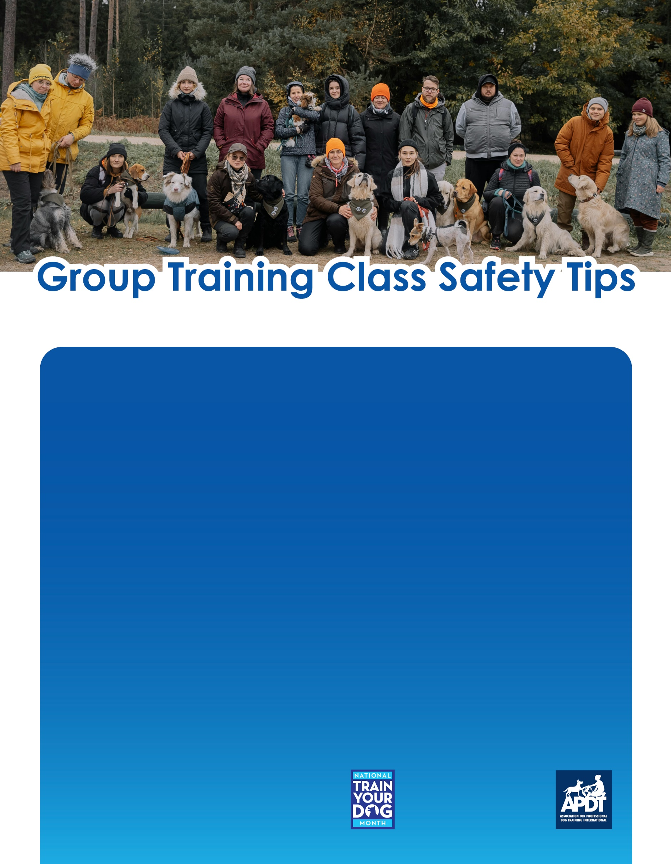

**[www.TrainYourDogMonth.com](http://www.TrainYourDogMonth.com) |** [**www.APDT.com**](http://www.APDT.com) **| [www.MyDogHasClass.com](http://www.MyDogHasClass.com)**

**Your Local APDT Member**

* If you have children that you want to involve in the process, discuss with your instructor first as each trainer has different policies in regards to children in class. If they do allow you to have your children attend, always be in control of the dog’s leash. Younger children may not have the strength to hold the dog, and also can be easily distracted. Likewise, supervise your children and ask other adults if they may meet their dogs first and instruct your children to respect their wishes regarding interaction with their dogs.
* Many dogs, particularly in the first night of class, can be very hyper and overly energetic because of the excitement of all the new dogs and people. Remember to stay calm and relaxed and do not get excited. Your dog will react to your body language and demeanor.
* If your dog is showing signs of illness, do not bring him to class, as he or she may pass it on to other dogs. This doesn’t mean you can’t show up though to observe what everyone else is learning!
* Always remember, it is your responsibility to protect your dog and watch out for him in a class situation. Always be aware of your dog’s actions, behavior and the environment around the both of you. Unless otherwise instructed by the course instructor, always keep hold of your leash.
* And most of all, remember to have fun learning with your dog!
* Make sure you dog’s collar or harness is properly sized. Dogs can get out of loosely fitted equipment. A good rule to follow is that there should be enough room to slip two fingers under the straps and no more.
* Dogs should have proper ID on their collars. While many owners are now microchipping their dogs, which we strongly encourage, having additional backup that can be easily seen if your dog gets lose can help get them home quicker.
* Always keep your dog on a 4 to 6 foot nylon, cloth or leather leash. Avoid using retractable leashes, which give you much less control over the dog and can be clumsy to handle. Avoid using chain leashes, which can be heavy and distracting to the dog.
* Maintain a distance of at least 4 to 6 feet between your dog and other dogs in the class. While other dogs may seem friendly, you don’t know how they will do with your particular dog, and their owners will appreciate you giving them space until everyone is comfortable with each other.
* Always watch your dog’s body language for signs of stress or agitation. A dog who’s tail is tucked, body is low to the ground, with sweaty paws, etc. is a dog that is fearful and needs more space, or to leave class entirely. Likewise, a dog that is staring, with body taut and hackles raised, is a dog that is not comfortable with the other dogs and might become aggressive. If your dog’s body language matches this description, move your dog away from the other dogs and consult the instructor. If you see other dogs with this body language, move away from them and give them space.

Group classes are a great way to help your dog become socialized to other dogs and people. They also learn how to do various behaviors in a distracting environment. There are some tips though that everyone should follow to make group classes a safe place for everyone.